

COMPANY PROFILE

^{PG} 01

INTRODUCTION

SCOPEX NIGERIA LIMITED is an outfit incorporated exclusively for rendering first class and multifaceted Environmental consultancy services to industries, oil/gas industries, banks, individuals, private firms, communities, agencies, government, and the general public.

MISSION STATEMENT POLICY

To render quality, non - defective

services, the first time, all the time.

VISION

To give our clients solutions that

add value to their operations and

giving them a competitive edge.

STRENGTH

- Effective quality assurance practice

- Best International standard laboratory protocols

- Highly trained employees

- Ability to deliver projects to budget and schedule

PG 02

OUR SERVICES

SCOPEX NIGERIA LIMITED is a core service provider in the following areas:

ENVIRONMENTAL SERVICES

Environmental Impact Assessment (EIA)

Our services involve identifying environmental impacts that a particular project might have and advise the client on mitigation measures, recognize the social impacts and participate in community meeting where we independently facilitate the views of the affected community.

Community and stakeholder consultation constitute an essential part of the environmental impact assessment (EIA) process and is a major aspect of the Scopex Laboratory's approach to executing a successful and discussion-based assessment and approvals process. Our clients also benefit from our state-of-the-art laboratory and monitoring facilities. We offer you guidance and assistance in complying with environmental regulations and in reducing your impact on the environment.

Environmental Evaluation Reports (EER)

Our models generate qualitative and quantitative description of already impacted environment. The model, also takes into cognizance the levels of significance for losses of environmental resources affected by the already existing installation/projects or action. We employ the NUPRC's systematic process in preparing EERs.

Environmental Compliance Monitoring (ECM)

The Environmental compliance monitoring programme is an environmental performance monitoring of production operations aimed at achieving continuous performance improvement with the ultimate goal of eliminating all negative impacts on the environment arising from

PG 03

production operations. The process involves continuous monitoring of identified parameters against regulatory limits set by NUPRC and FMENV (WHO for ground water) towards continuous improvement.

Environmental Audit Report (EAR)

We adopt the regulatory environmental management tool for measuring the effects of operational activities on the environment against set criteria or standards. This periodic exercise will evaluate how well your organisation, management and equipment are performing with the aim of helping to safeguard the environment by facilitating management control of practices and assessing compliance with company regulatory requirements and standards applicable.

Environmental Management Review

Before developing environmental management systems or before and after any significant changes in operations, the company is required to review its activities to set policies and procedure that will promote sound environmental conditions.

Environmental Baseline Studies (EBS)
Scopex Nigeria Limited carries out an Environmental Baseline Study surveys to determine the characterization of an area prior to the development of a project and establish the initial environmental status.

Other Environmental Services we provide include:

- Seabed Survey

- Sludge treatment, evacuation and disposal

- Site restoration / remediation

- Noise abatement strategies

- Risks Assessment and Management

- Waste Management

- Oil Recovery Equipment

- Biological Sludge Treatment

- Post Impact Assessment (PIA)

PG 04

SCOPEX NIGERIA LIMITED STAFF

ORGANIZATIONAL STRUCTURE

ORGANIZATIONAL STRUCTURE OF SOPEX NIGERIA LIMITED

CORE CONSULTANCY SPECIALIST TEAM

MANAGING DIRECTOR/ CEO

PROJECT MANAGER

SENIOR | HSE COORDINATOR | OPERATIONS
CHEMIST/ PROJECT | HSE COORDINATOR | OPERATIONS
CHEMIST/ PROJECT | SAFETY OFFICER | MANAGER
COORDINATOR | SAFETY OFFICER | MANAGER

SECTORAL | CONSULTANTS | ADMINISTRATIVE
TECHNICIANS | AND OTHER | ADMINISTRATIVE
TECHNICIANS | AND OTHER | PERSONNEL
PROFESSIONALS |  | PERSONNEL

In addition to the above listed personnel, scopex nigeria limited has an arrangement to co-opt other sectorial specialist resource consultants depending on the specific need of the consultancy requirements of any contract to be executed.

PG 05


TESTING SERVICES

Scopex offers integrated environmental services and analytical testing. We provide organic, inorganic, and trace level contaminants in air, water, soil and waste analytical services.

Our testing services include aquatic toxicity, drinking water, metals, low level mercury, stack emission testing, ambient air monitoring, Soil analysis, groundwater, wastewater monitoring, Oil Fingerprinting and much more.

Soil Analysis

The chemical soil analysis or soil testing is a rapid and inexpensive process of obtaining information on nutrient availability in soils as a basis for certain recommendations. We performs testing on routine parameters like heavy metals, TPH, PAH, BTEX, aromatics, and pesticides, as well as nonstandard parameters. We use recent technologies offered on AAS, GC/MS, and HPLC for analysis.

Water
Water is object of numerous environmental laws and regulations. This relates not only to drinking water but ultimately also for the whole water cycle, for example surface and ground water, process and waste water. Scopex with its wide range of assays in water analysis is your partner for all physical and chemical testing. Scopex with its wide range of assays in water analysis is your partner for all physical and chemical testing.

Waste

We analyze all waste classified as generic waste according to Industry legislation. We are able to provide analytical capabilities which cover waste characterization and composition, waste acceptance criteria (WAC) for wastes. Example asbestos, slack, sludge.


PG 06

Oil Fingerprinting

Petroleum biomarkers are “molecular fossils” that can be analyzed with gas chromatography to fingerprint crude oil. Using samples from your soil and water, Scopex conducts hydrocarbon fingerprinting, an environmental forensic test that enables us to evaluate the release of petroleum in soil, sediment and water. The data generated helps to; Identify the source of contamination (your site or neighbouring facility) Track the timeframe for contamination (for instance previously used industrial site) Differentiate between pollutants from oil and petrol and biogenic sources such as plant material

Air Quality Monitoring

Our air quality testing services cover: Workplace monitoring Sox, Nox, CO2, H2, H2S, Dust particle pollution, Volatile organic compounds, Asbestos, man-made and mineral fibers and crystalline silica Odor measurements
Continuous air monitoring networks

Gas Dispersion Modelling

Furthermore, using flow and dispersion modelling, we give you a clear picture of how flammable gas spreads under various wind conditions, and this help you in designing your facility and constructing rules for various activities.

Biotoxicity

To register a new chemical, companies are required to conduct specific toxicity tests by regulators. Regulators uses this models to predict a chemical's toxicity on the basis of its potential risk to the environmental. We carry out toxicity test on organisms exposed to these chemicals routinely. On the basis of obtained data, ecotoxicological properties of substances, chemical products and wastes are assessed.


PG 07

EXPLORATION & PRODUCTION TESTING SERVICES

- Crude Assay2 Natural Gas Analysis

3 PVT 4 Flow Assurance

- Production Chemistry

CRUDE ASSAY

Crude oil assay for exploration and production is integral to establishing and understanding the composition of petroleum reserves and their viable commercial uses. Having a complete characterization of your crude oil not only facilitates the job of the refinery team, but also puts business planners in the best possible position to maximize profits. Scopex Crude Oil Assay testing laboratories provide the molecular and chemical characterizations of crude oil.

We generated data like

- Sulfur content

- Nitrogen content

- Viscosity measurements

- Asphaltene & Waxes Deposition

- Methanol in crude

- ARA Analysis

- Cloud Point & Pour Point
Using ASTM and other industry standards and protocols.

PG 08

GAS ANALYSIS

Scopex provides reservoir gas composition testing, including routine C1 to C7+ testing and extended gas analysis, and determination of inorganic gases like CO2 and N2. Our regular gas analysis also ensures that the quality of gas and efficiency of turbine scrubbers are in line with the design to secure your investment on the power facility.

Professional sampling and analysis services for the determination of; Sulphur based elements such as H2S and Mercaptans Calculation of Calorific Value Relative Density and Compressibility Factor. Gas Hydrates Evaluation and Testing Dewpoint, LPG and LNG Testing and Inspection, Natural Gas Testing and in reducing your impact on the environment.

PVT ANALYSIS

PVT studies can be carried out on a complete range of reservoir fluid types including gas condensates, black oils, and critical fluids. Representative samples are examined at actual reservoir pressures and temperatures to determine phase behaviour and compositional changes through the life of the reservoir as pressure declines.

Phase Behaviour (PVT) analysis needs to be performed on representative fluid samples collected at the earliest opportunity, normally during the drilling of the first exploration well and certainly before the reservoir is put into full production. This highly specialized form of analysis delivers results for reservoir engineering purposes and also supports the design and optimization of processes and facilities. Scopex Laboratory offers a comprehensive range of standard and customized PVT testing services to suit your needs.

PG 09

FLOW ASSURANCE

Scopex provide accurate analysis and interpretation in a range of multi-disciplinary flow assurance testing.

Our flow assurance testing program includes:

- Wax appearance temperatures (WAT)

- Asphaltene solubility boundaries

- Chemical Efficacy (Bottle Test)

- Hydrate association

- Scale solubility boundaries and analysis of scale deposits

- Screening tests for potential organic solids

- Advanced water chemistry tests

PRODUCTION
CHEMISTRY

Production chemistry analysis ensures control over the performance of your oil and gas reservoirs. Our testing program allows you to understand and minimize the impact of scale, corrosion and acidization compatibility on the productivity of your reservoir. We can generate data that measures the preformation of chemical and aids optimization.

Our production chemistry testing includes:

- BS&W

- KF water content

- Density

- Viscosity

- Crude salinity

- Gas chromatography

- Gas dewpoints

- Trace sulfur analysis

- Bottle Test and Chemical Efficacy

- Corrosion Monitoring

PG 10


CORROSION MONITORING

Internal Corrosion Monitoring
Corrosion Monitoring is one of the basic needs of safe and efficient industrial operation especially hydrocarbon industry, chemical processing industry, power plants and refineries. Corrosion can lead to structural failure or loss of containment, costly repairs, lost or contaminated products, environmental damage, risk to personnel, and loss of public confidence.

Scopex employs educational resources to provide access to sophisticated analytical equipment to provide innovative solutions related to corrosion and specialty chemical monitoring.

We are dedicated to providing internal corrosion monitoring solutions to onshore and offshore oil and gas producers and process industries. Primary services include solutions relating to

- Hydraulic access fitting field service

- Electronicmonitoring (ER Measurement),

- Monitoring equipment supply and specification,

- Weight-loss corrosion coupon analysis

- Sessile / planktonic bacterial sampling and reporting.

Additional services include field sampling (Water, Fe/Mn, CI residuals) and onshore pipeline external coating inspections.

We can provide audit services related to internal corrosion monitoring and production specialty chemical usage. Proper monitoring should ensure that all mitigation strategies have the potential to be evaluated.

PG 11

SITE CLEAN-UP SERVICES

- Environmental project supervision and monitoring consultancy services

- Sustainable Development Initiatives

- Safety Training and Consultancy(onshore/offshore/fire)

- Quality Control and Quality Assurance Services

- Supply Services (oil/gas equipment)

- Logistics and Nigeria Manpower Development / Supply

- Potable /Waste Water Treatment and Analysis

- Fisheries / Aquaculture / Livestock Consultancy

- Community conflict mediation / resolution services

- Youth Empowerment Programmes etc.


CIVIL ENGINEERING SERVICES

The highly qualified team at SCOPEX NIGERIA LIMITED can offer complete engineering services from the project feasibility phase through to detailed design and construction management.
PG 12

1

2

3

4

5

6

7

8

9

10

11

12

OUR CLIENTS
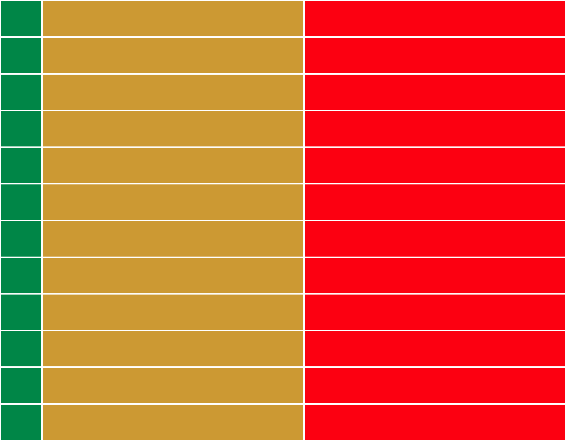
N.D.D.C PORT HARCOURT.

UNIVERSAL ENERGY RESOURCES LIMITED AWKA IBOM

NIMASA LAGOS/PORT HARCOURT/AKWA-IBOM

MOBIL PRODUCING UNLIMITED EKET

N.A.O.C PORT HARCOURT.

NIGERIAN PORTS AUTHORITY LAGOS/PORT HARCOURT.

SOLEWANT GROUP PORT HARCOURT.

ANAMBRA STATE GOVERNMENT AWKA

WEST AFRICAN GLASS INDUSTRY PLC. TRANS - AMADI, PORT HARCOURT.

CENTRICA RESOURCES NIG. LTD. LAGOS/ AWKA IBOM

EMO ASHAPURA ENERGY & MINING LTD. ABUJA/ CROSS RIVER

SUMMIT INT. CONSULTANT LTD. BENIN CITY/ U.S.A



85 Aker Road Off Iwofe Road,

Port Harcourt, Rivers State.

www.scopex.org scopex2@gmail.com

+234 (0) 803 310 0229, +234 (0) 802 700 9480

